Homeworks
所有作业必须独立完成；
非代码类作业，手写完成，完成后通过拍照方式粘贴至word文档，并转存为pdf文档，pdf文档命名为 hwk#_学号_姓名，其中#表示第几次作业。 比如张三的学号是123，完成第三次作业后，提交的作业文件是‘hwk3_123_张三.pdf’。

代码类作业，不需要提交项目文件，只提交.CPP和.H
阅读类作业无需提交

每次作业如果有多个文件须将所有需提交的文件打包为压缩文件(zip或rar均可)，打包后，压缩文件命名为”hwk#_学号_姓名”。

作业须在提交截止时间之前提交到课程中心上；
整个课程期间，无特殊情况，不接受作业的补交！
未提交的作业的，当次作业计分为零。
最终作业考核分为各次作业的平均分。

- Homework1 (deadline 2025-09-20)
  - Read textbook Ch2. Please pay more attention on section 2.4.3 “the Maximum Subsequence Sum Problem” (do not need to be submitted)
  - Read textbook Ch3. (do not need to be submitted)
  - Exercises from textbook
    - (Exercise2.7 (4)(5)(6)) For each of the following 3 program fragments:
- Give an analysis of the running time (Big-Oh will do).
- Implement the code in the language of your choice, and give the running time for several values of N. (Refer to textbook section 2.3. Give the running time as shown in figure 2.2)
- Compare your analysis with the actual running times. (Refer to textbook section 2.3; It is recommended to use software like MS excel)
// ALG1
sum = 0;
for( i = 0; i < n; ++i )
for( j = 0; j < i; ++j )
++sum;

//ALG2
sum = 0;
for( i = 0; i < n; ++i )
for( j = 0; j < i * i; ++j )
for( k = 0; k < j; ++k )
++sum;

//ALG3
sum = 0;
for( i = 1; i < n; ++i )
for( j = 1; j < i * i; ++j )
if( j % i == 0 )
for( k = 0; k < j; ++k )
++sum;

    - (From exercise 2.14 )Consider the following algorithm (known as Horner’s rule) to evaluate $f\left(x\right)=\sum_{i=0}^{N}{a_{i}x^{i}}$:
poly = 0;
for( i = n; i >= 0; --i )
poly = x * poly + a[i];
- Show how the steps are performed by this algorithm for $x=3,f\left(x\right)=4x^{4}+8x^{3}+x+2$
- What is the running time of this algorithm?

    - (Form Exercise 3.28) A deque is a data structure consisting of a list of items on which the following operations are possible:
push(x): Insert item x on the front end of the deque.
pop(): Remove the front item from the deque and return it.
inject(x): Insert item x on the rear end of the deque.
eject(): Remove the rear item from the deque and return it.
Write routines to support the deque that take O(1) time per operation.
(需要描述基本设计思想，可以在代码中以注释形式撰写)

    - (Form Exercise 3.30) Implementations of self-adjusting lists. In a self-adjusting list, all insertions are performed at the front. A self-adjusting list adds a find operation, and when an element is accessed by a find, it is moved to the front of the list without changing the relative order of the other items. (需要描述基本设计思想，可以在代码中以注释形式撰写)
- Write an array implementation of self-adjusting lists.
- Write a linked list implementation of self-adjusting lists.
- Compare time complexity of insert operation and find operation between the two implementations. (在各自的实现代码中以注释形式描述)

    - To implement two stacks in one Array. (需要描述基本设计思想，可以在代码中以注释形式撰写)

- Homework2 (deadline 2025-10-13)
  - Read textbook Ch4, especially some examples like those in Sections 4.1.2, 4.2.2. (do not need to be submitted)
  - Exercises from textbook
- What is the depth of the tree in the below figure? (Exercises 4.3)
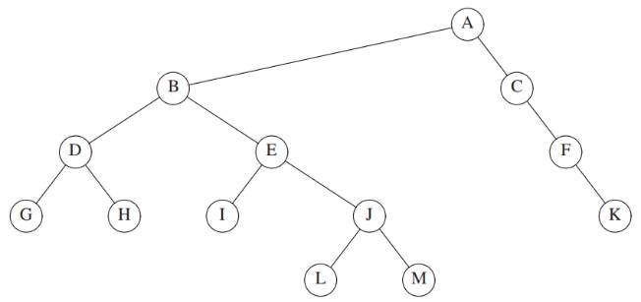
- Show that the maximum number of nodes in a binary tree of height h is 2^{h+1} – 1. (Exercises 4.5)
- Show the result of inserting 3, 1, 4, 6, 9, 2, 5, 7 into an initially empty binary search tree. And show the result of deleting the root. (Exercises 4.9) (需要以图形化方式给出插入和删除的每个步骤，)
- Give a precise expression for the minimum number of nodes in an AVL tree of height h. What is the minimum number of nodes in an AVL tree of height 15? (Exercises 4.18)
- Show the result of inserting 2, 1, 4, 5, 9, 3, 6, 7 into an initially empty AVL tree. (Exercises 4.19) (需要以图形化方式给出插入的过程每个步骤)
- Show the result of accessing the keys 3, 9, 1, 5 in order in the splay tree in the below figure, and show the result of deleting the element with key 6 in the resulting splay tree. (需要以图形化给出包含每步访问、删除的过程),
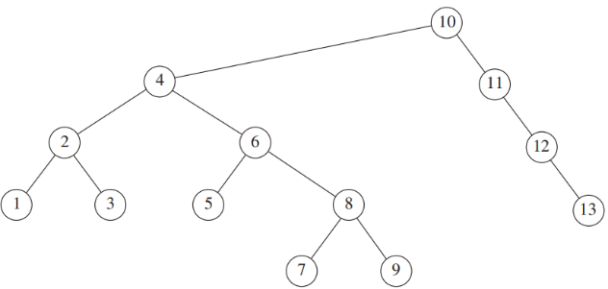
  - Show the result of inserting the records U and R in order into B⁺-Tree with order 4 as shown below. Assume that the leaf nodes are capable of storing up to 3 records. (需要以图形化给出包含每步插入的过程)
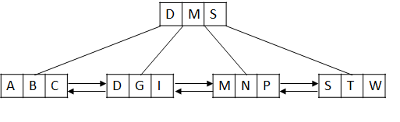

- Homework3(deadline 2025-11-02)

  - Exercises from textbook
- (textbook exercise 5.1) Given input {4371, 1323, 6173, 4199, 4344, 9679, 1989} and a hash function h(x) = x mod 10, show the resulting
  - separate chaining hash table
  - hash table using linear probing
  - hash table using quadratic probing
  - hash table with second hash function h2(x) = 7 − (x mod 7)
- (textbook exercise 6.2,6.3)
  - Show the result of inserting 10, 12, 1, 14, 6, 5, 8, 15, 3, 9, 7, 4, 11, 13, and 2, one at a time, into an initially empty binary heap.
  - Show the result of using the linear-time algorithm to build a binary heap using the same input.
  - Show the result of performing three deleteMin operations in the heap of the exercise a) and b).
- (textbook Exercise 7.2) What is the running time of insertion sort if all elements are equal?
- (textbook Exercise 7.11) Show how heapsort processes the input 142, 543, 123, 65, 453, 879, 572, 434, 111, 242, 811, 102. (图形化方式给出包含每步的过程)
- (textbook Exercise 7.12) What is the running time of heapsort for presorted input?
- (textbook Exercise 7.15) Sort 3, 1, 4, 1, 5, 9, 2, 6 using mergesort.(图形化方式给出包含每步的过程)
- (textbook Exercise 7.19) Sort 3, 1, 4, 1, 5, 9, 2, 6, 5, 3, 5 using quicksort with median-of-three partitioning and a cutoff of 3. (图形化方式给出包含每步的过程)
- (textbook Exercise 7.20) Using the quicksort implementation in this chapter, determine the running time of quicksort for
  - sorted input
  - reverse-ordered input
  - random input
- (textbook Exercise 7.31) A sorting algorithm is stable if elements with equal elements are left in the same order as they occur in the input. Which of the sorting algorithms you have learned are stable and which are not? Why?
- Try to implement all the sorting algorithms you have learned with C++.(do not need to be submitted)

- Homework4(deadline 2025-11-30)
  - Exercises from textbook
- (textbook Exercise 8.1) Show the result of the following sequence of instructions: union(1,2), union(3,4), union(3,5), union(1,7), union(3,6), union(8,9), union(1,8), union(3,10), union (3,11), union(3,12), union(3,13), union(14,15), union(16,0), union(14,16), union (1,3), union(1, 14) when the unions are
a. performed arbitrarily
b. performed by height
c. performed by size
- (textbook Exercise 8.2) For each of the trees in the previous exercise, perform a find with path compression on the deepest node.
- (textbook Exercise 9.1) Find a topological ordering for the graph in the following figure.
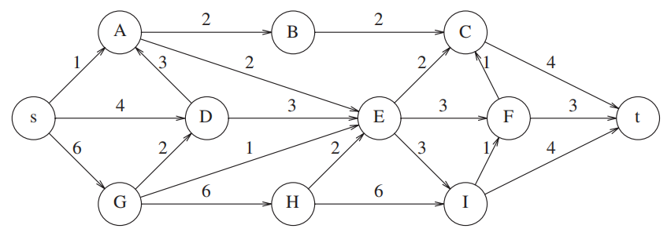
- (textbook Exercise 9.5)
- Find the shortest path from A to all other vertices for the graph in the following figure.
- Find the shortest unweighted path from B to all other vertices for the graph in the following figure.
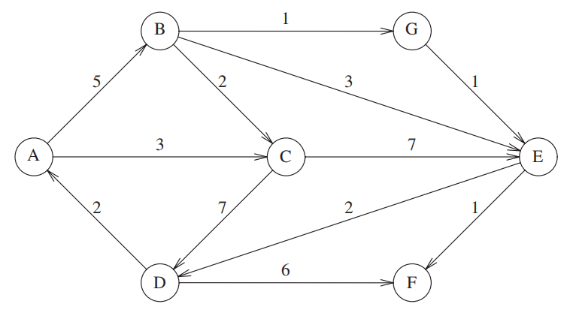
- (textbook Exercise 9.15)
- Find a minimum spanning tree for the graph in the following figure using both Prim’s and Kruskal’s algorithms.(图示的方式描述两个算法的处理过程)
- Is this minimum spanning tree unique? Why?
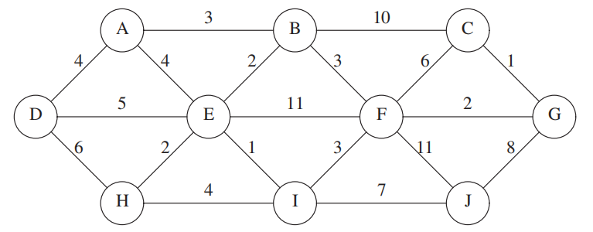
- (textbook Exercise 9.26) Find the strongly connected components in the graph. (Depth-first search)
